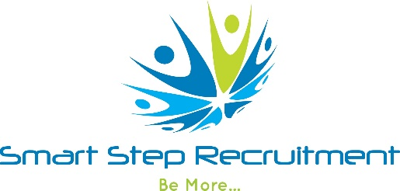
rachel@smartsteprecruitment.co.uk
0203 355 4480

Successful Tips for your Interview

Preparation The short time you spend at a job interview could have significant effect on your career prospects. It is important that you prepare adequately for the interview as this remains an extremely important step to achieving your career ambitions. Preparing well beforehand can mean the difference between SUCCESS and FAILURE.

- Make sure you know exactly what is written on your CV and that you talk about your work experience in detail. Refresh your memory on the facts and figures of your present and former employers. You will be expected to know a lot about the company for which you have previously worked.
- Find out exactly how to get to the offices where your interview is being held and how long the interview is expected to take. Allow plenty of time for the journey. Being late for your interview is NOT acceptable.
- Check with your agency who you need to ask for on arrival and who will be carrying out the interview.
- Discuss the structure of the interview with your consultant and check if you will be expected to complete any tests.
- Carry out some research on the company. Your consultant will be able to provide you with background information, but ALWAYS look at their website beforehand. Check what the role you are applying for actually entails.
- Prepare question to ask during the interview. Take a list of questions with you to refer to. This shows you have taken the time to prepare.

POSSIBLE QUESTIONS YOU MAY ASK….

- A detailed description of the position?
- Reason the position is available?
- Culture of the company?
- Company growth plans?
- Anticipated induction and training?
- Best selling products or services?
- The next step?

DRESS CODE

- Dress smartly and conservatively.
- Never wear denim or leather garments
- For ladies, avoid too much make up and low cut or see through blouses.
- For males, a dark suit is best and ensure you wear a tie. Make sure your shoes are clean and that you are clean shaven.

QUESTIONS TO EXPECT...

- Why did you choose this particular role?
- What do you know about our company?
- What are your career plans?
- What style of management gets the best from you?
- Why did you leave your last job?
- What does team work mean to you?
- What was your last salary including bonus?
- What did you enjoy most about your last job?
- What did you least enjoy about your last role?

NEGATIVE FACTORS

During the interview the employer will be watching for negative factors as well as your positive attributes. During an interview there are several factors which often lead to rejection. WATCH OUT FOR…..

- Poor personal appearance.
- Aggressive, conceited, superiority complex, know it all.
- Lack of planning - no goals
- Lack of interest and enthusiasm. No eye contact.
- Condemnation of past employers, no matter what has happened NEVER run down a past employer. Be honest but diplomatic.
- Lack of confidence, nervousness.
- Over emphasis on MONEY
- Limp handshake.
- Failure to ask good questions about the company and job role.

DURING YOUR INTERVIEW

- Greet the interviewer with a firm handshake.
- Sit up straight, don’t slouch.
- Maintain eye contact and show an interest throughout the interview.
- Let your personality come through.
- Answer questions clearly and concisely, don’t waffle.
- When talking about your past jobs, emphasise any achievements, prizes won.
- Make in clear you have done your homework and tell them what you know about the company.
- Do not bring up the subject of salary first. This is something the interviewer will discuss with you at the appropriate time.
- SMILE.
- Towards the end ask the questions you have prepared.
- Thank the interviewer for their time and say you have enjoyed meeting them.
- Close the interview but asking what the next stage is, if you are keen on the job tell them.

AFTER THE INTERVIEW.
Call your consultant as soon as possible. They will debrief you and speak to the client on your behalf. Be honest if you have any concerns. If you are not interested in the role don’t be afraid to tell the consultant why, it will help when searching for further opportunities.

GOOD LUCK!!!

